

**New York University Abu Dhabi**

**Fall 2017**

**Introduction to Computer Science**

**Final Project Write-up**

**Drift Velocity: A Racing Arcade**

**Team Members:**

**1. Wahib Kamran (wk738)**

**2. Aman Pandey (ap5275)**

About the game:

This game is an adaptation of Hill Climb Racing. It is a single player adventure game in which the player has to guide Faiza the Falcon from the desert all the way to the NYUAD campus by avoiding the obstacles (such as sand dune, cactus, palm tree, excavator, etc.) spread across the route. Colliding with an obstacle will result in the player shifting from the bike to a camel which will result in lower velocity. The player can also gain a turbo pack (that will last for 4 seconds) or shift back from a camel to the car by collecting 5 coins (coins are spread throughout the route). The time it takes for a player to complete the journey will be recorded and the winner will be decided on the basis of the shortest time taken to reach the NYUAD campus.

How to play:

A player is required to type in their name in the menu screen so that their score could be recorded. The game will begin as soon as the ‘PLAY’ button on the menu screen is clicked. For the gameplay, conventional key methods have been adapted. Arrow keys would be used to move the character (jump with ↑ key; move right with → key; move left with ← key). A player can pause the game by pressing the ‘P’ key. Once the finishing line has been crossed, the player will see their score on the screen. To check the overall high scores, the player can simply click anywhere on the screen. Once on the high scores page, clicking on the screen will result in the game being redirected back to the menu page in order to play the game again.

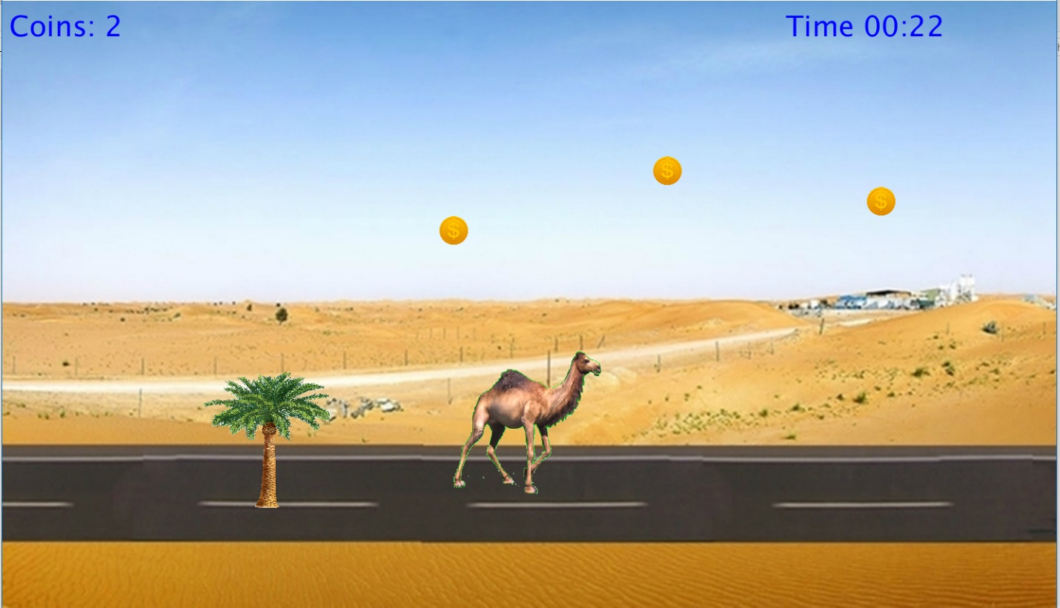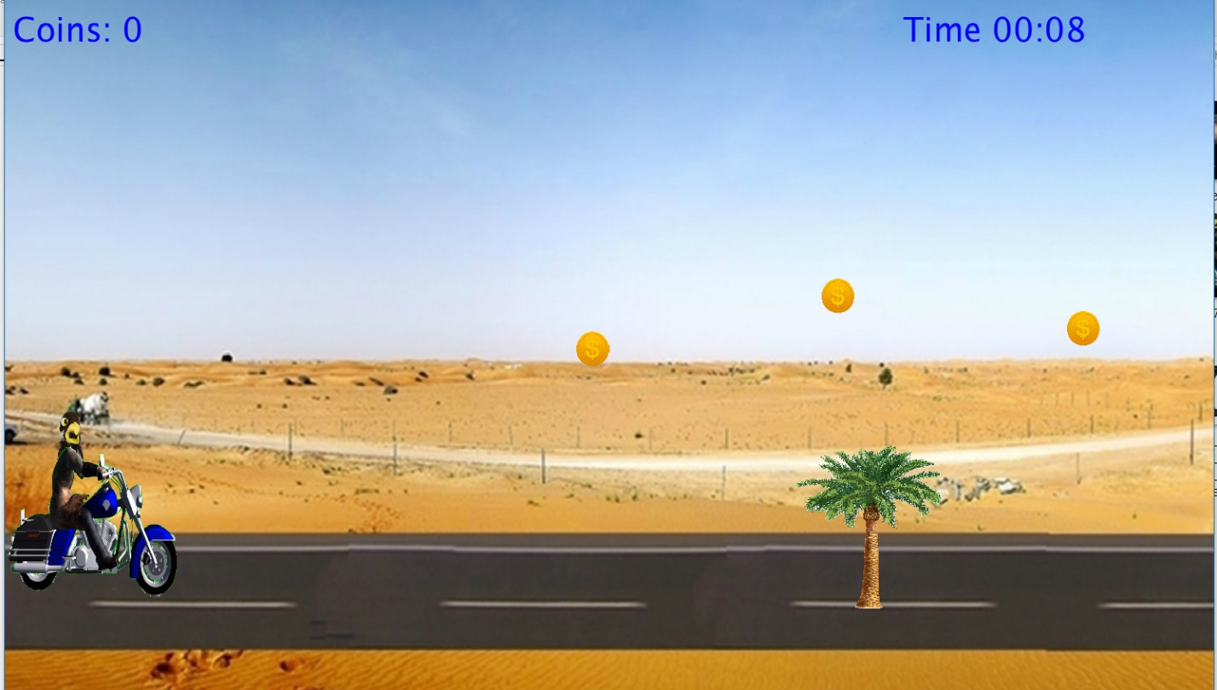Screenshots:

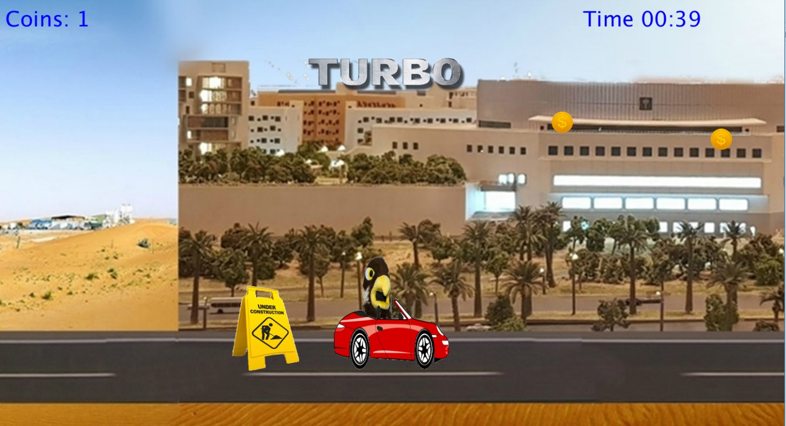

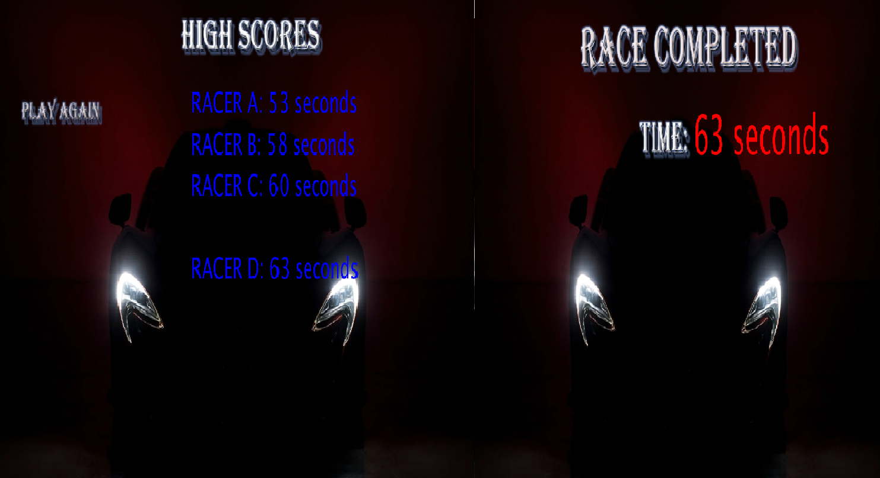

THANK YOU!